Counterclockwise Orientation

Definition
# Source: AI Source: Provided by: [Data Path: Persons Table -> ID Column: 1, Name_En Column: Motasem Essam] -> From: [ChatGPT] on [7/20/2026]
Counterclockwise Orientation describes the direction in which an object is rotated opposite to the movement of a traditional clock's hands. The rotation proceeds from the top toward the left, then downward, rightward, and back upward.
Counterclockwise orientation is the standard positive direction of rotation in mathematics and is widely used in geometry, trigonometry, physics, engineering, robotics, navigation, and computer graphics.

Characteristics
# Source: AI Source: Provided by: [Data Path: Persons Table -> ID Column: 1, Name_En Column: Motasem Essam] -> From: [ChatGPT] on [7/20/2026]
A counterclockwise orientation:
- Rotates opposite to the direction of a clock's hands.
- Represents rotation, not translation.
- Changes the direction of an object without changing its size or shape.
- Is measured relative to a reference direction.
- Is commonly represented using positive angles in mathematics.

Illustration
# Source: AI Source: Provided by: [Data Path: Persons Table -> ID Column: 1, Name_En Column: Motasem Essam] -> From: [ChatGPT] on [7/20/2026]
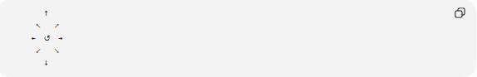
↑
↖ ↗
← ↺ →
↙ ↘
↓
The curved arrow indicates counterclockwise rotation.

Counterclockwise Rotation
# Source: AI Source: Provided by: [Data Path: Persons Table -> ID Column: 1, Name_En Column: Motasem Essam] -> From: [ChatGPT] on [7/20/2026]
If an object starts facing upward, a counterclockwise rotation changes its orientation as follows:
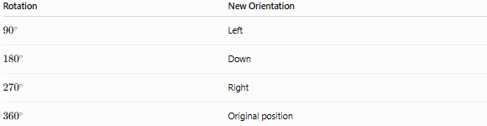
Rotation | New Orientation
$${90}^{∘}$$ | Left
$${180}^{∘}$$ | Down
$${270}^{∘}$$ | Right
$${360}^{∘}$$ | Original position

Angle Measurement
# Source: AI Source: Provided by: [Data Path: Persons Table -> ID Column: 1, Name_En Column: Motasem Essam] -> From: [ChatGPT] on [7/20/2026]
Counterclockwise orientation is commonly represented by positive rotation angles.
Examples:
- ${45}^{∘}$
- ${90}^{∘}$
- ${180}^{∘}$
- ${270}^{∘}$
- ${360}^{∘}$
In standard mathematics:
- Positive angles → Counterclockwise
- Negative angles → Clockwise
Example:
$$+{90}^{∘}$$
represents a 90° counterclockwise rotation.

Examples
# Source: AI Source: Provided by: [Data Path: Persons Table -> ID Column: 1, Name_En Column: Motasem Essam] -> From: [ChatGPT] on [7/20/2026]
Counterclockwise orientation can be observed in:
- Rotating coordinate systems
- Mathematical angle measurement
- Compass and navigation calculations
- Computer graphics transformations
- Robotic arm movement
- Mechanical simulations
- Educational geometry models

Applications
# Source: AI Source: Provided by: [Data Path: Persons Table -> ID Column: 1, Name_En Column: Motasem Essam] -> From: [ChatGPT] on [7/20/2026]
Counterclockwise orientation is used in:
- Geometry
- Trigonometry
- Coordinate Geometry
- Engineering
- Robotics
- Physics
- Computer Graphics
- CAD (Computer-Aided Design)
- Animation
- Navigation

Advantages
# Source: AI Source: Provided by: [Data Path: Persons Table -> ID Column: 1, Name_En Column: Motasem Essam] -> From: [ChatGPT] on [7/20/2026]
Counterclockwise orientation:
- Provides the standard positive rotation direction in mathematics.
- Simplifies angle measurement.
- Supports geometric transformations.
- Improves consistency in mathematical calculations.
- Enables accurate graphical representation.

Limitations
# Source: AI Source: Provided by: [Data Path: Persons Table -> ID Column: 1, Name_En Column: Motasem Essam] -> From: [ChatGPT] on [7/20/2026]
Counterclockwise orientation:
- Depends on the observer's viewpoint.
- Requires a defined reference axis.
- Engineering disciplines may use different sign conventions in some contexts.

Comparison with Other Orientations
# Source: AI Source: Provided by: [Data Path: Persons Table -> ID Column: 1, Name_En Column: Motasem Essam] -> From: [ChatGPT] on [7/20/2026]
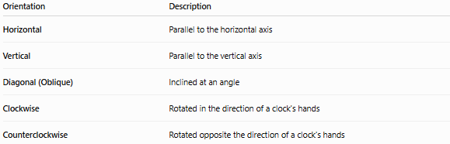
Orientation | Description
Horizontal | Parallel to the horizontal axis
Vertical | Parallel to the vertical axis
Diagonal (Oblique) | Inclined at an angle
Clockwise | Rotated in the direction of a clock's hands
Counterclockwise | Rotated opposite the direction of a clock's hands

Key Points
# Source: AI Source: Provided by: [Data Path: Persons Table -> ID Column: 1, Name_En Column: Motasem Essam] -> From: [ChatGPT] on [7/20/2026]
- Counterclockwise Orientation follows the direction opposite to a clock's hands.
- It represents rotational direction, not position.
- In mathematics:
  - Positive angles represent counterclockwise rotation.
  - Negative angles represent clockwise rotation.
- Counterclockwise orientation is the standard convention used in geometry, trigonometry, physics, and computer graphics.

Conclusion
# Source: AI Source: Provided by: [Data Path: Persons Table -> ID Column: 1, Name_En Column: Motasem Essam] -> From: [ChatGPT] on [7/20/2026]
Counterclockwise Orientation describes the rotational direction opposite to the movement of a clock's hands and serves as the standard positive direction for measuring angles in mathematics. It is fundamental to geometry, trigonometry, coordinate systems, engineering, robotics, computer graphics, navigation, and scientific analysis, where consistent representation of rotational direction is essential for accurate calculations, transformations, and spatial reasoning.

